2nd grade: Energy Cycle

Read students the book: “Living Sunlight: How plants bring the earth to life” by Molly Bang (http://www.amazon.com/Living-Sunlight-Plants-Bring-Earth/dp/0545044227)

(consider also reading “My Light” by Molly Bang just about the sun as an energy producing star!)
http://www.amazon.com/My-Light-Molly-Bang/dp/043948961X/ref=sr_1_1?s=books&ie=UTF8&qid=1430412882&sr=1-1&keywords=my+light+by+molly+bang

from the book… “YOU are living sunlight” asks kids to feel their heartbeat and breathe in oxygen and out CO2 etc. to ‘feel’ the energy inside them that originally came from the sun! Students are a part of the energy cycle just like all living things play a role…

Students (alone or in pairs) use chalk to draw their own pictures of energy cycles on the garden’s sidewalk. Without the sun there would be no life on earth!

Sun – photosynthesis transfers energy to plants in form of carbs/sugars - plant has edible parts - animals eat plants - people eat animals – animals disperse/ people plant seeds - seeds germinate into plants – plants use sun to grow - cycle starts over again (you can also discuss how O2 and CO2 are involved)

End the lesson by having students plant seeds as planting “future energy”!
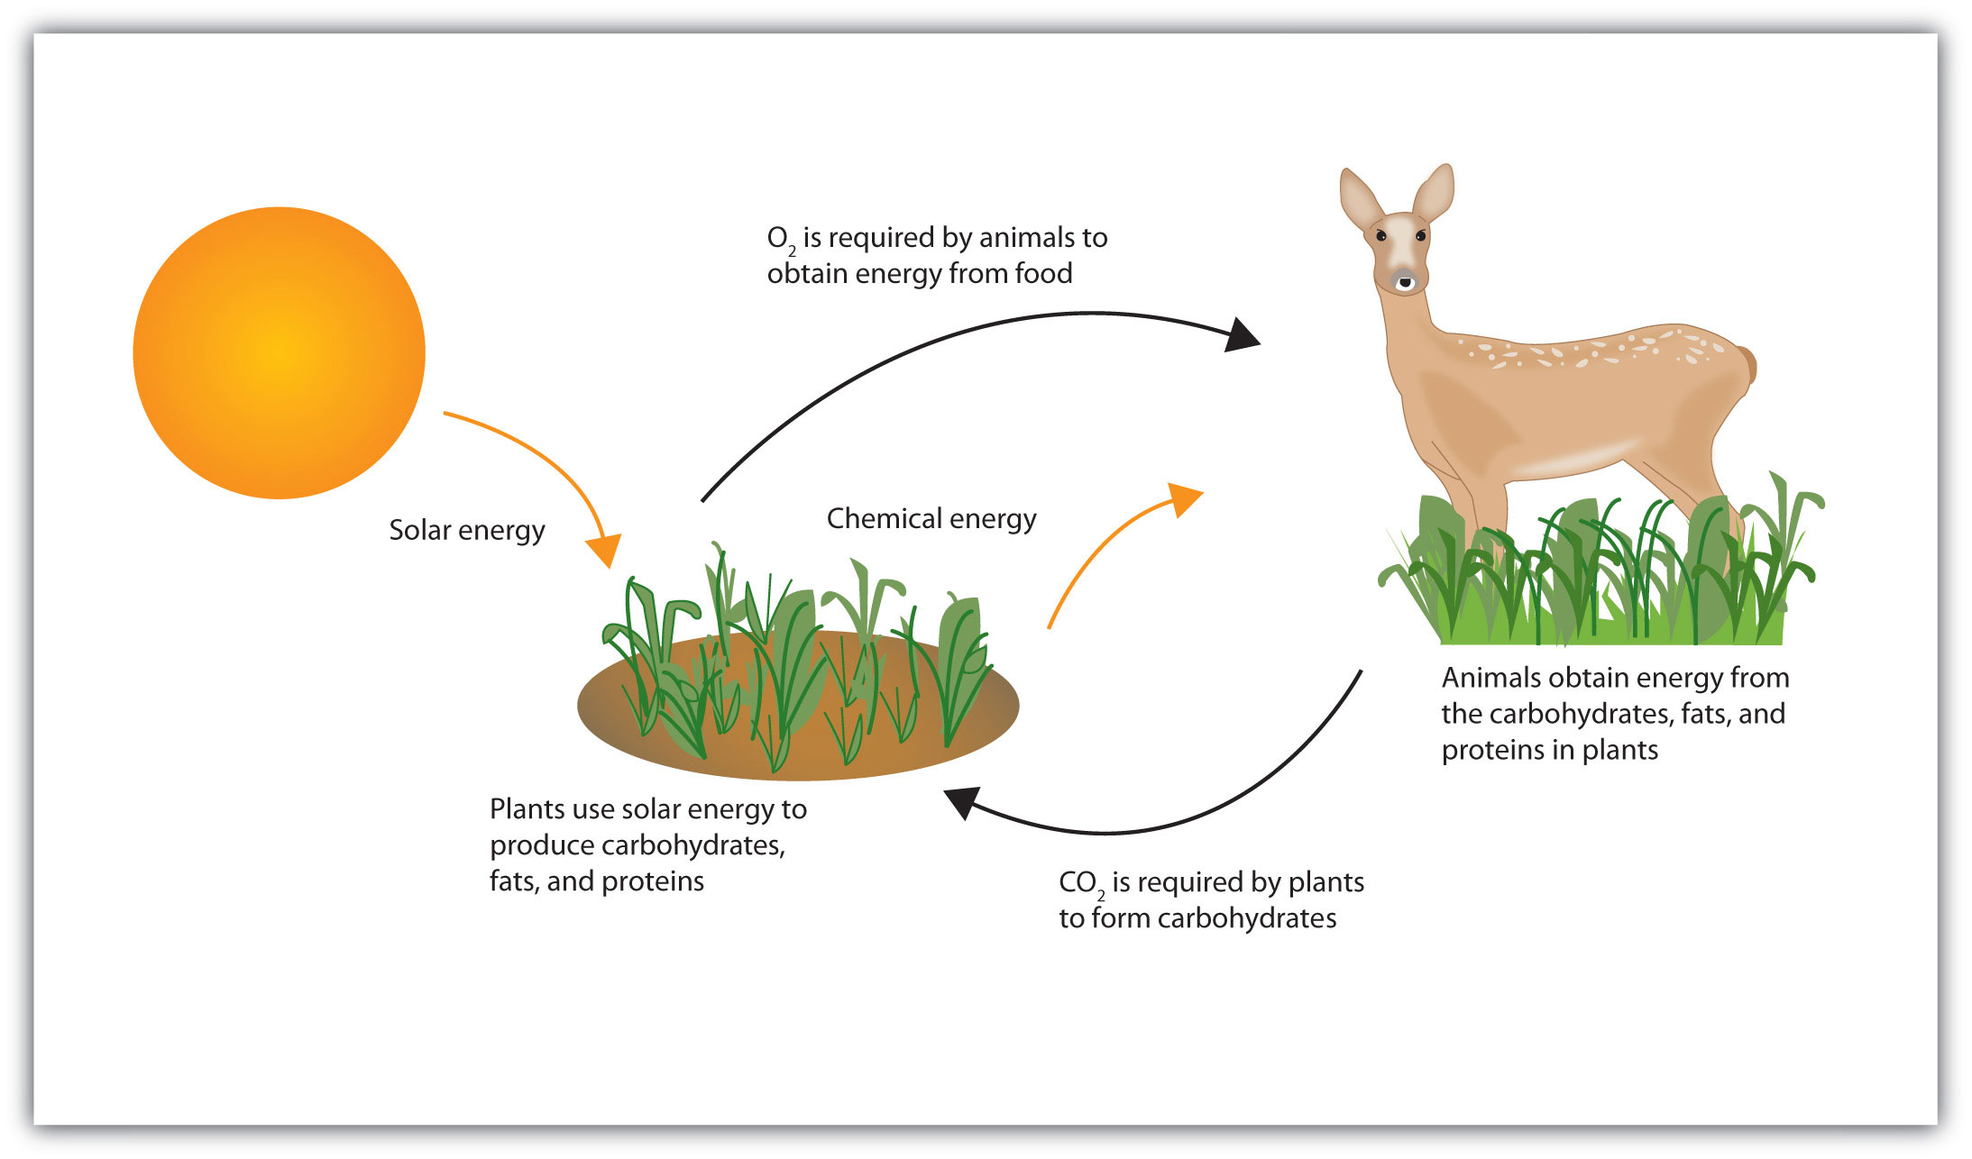

(scroll down for very basic photosynthesis worksheet)
